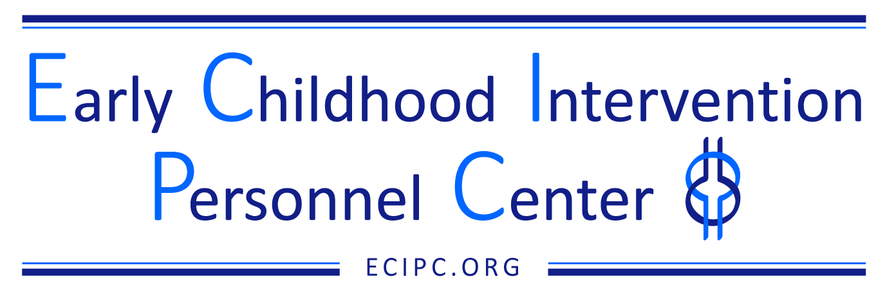

IHE Curriculum/Program of Study Self-Assessment Checklist

This checklist is designed for program self-assessment for an Early Intervention/Early Childhood Special Education (EI/ECSE) or a blended Early Childhood Education and EI/ECSE curriculum or program of study at an approved Institution of Higher Education (IHE).

Name:
University:
Title of Degree Program:
Level of Degree (e.g., B.S., M.ED., M.S., M.A., 6th year; Ph.D., E.D., Certificate):
Date Submitted:
Coordinated with State CSPD: Yes/No

Step | Things to Do/Consider | Yes | No | In Process | Notes
- Getting started: Self Study | Establish the faculty planning team, curriculum committee and other strategic partners.  - Identify core faculty planning team (i.e., program faculty involved)  - Consult curriculum committee (if applicable)  - Identify strategic partners (e.g., dean, department chair, etc.)
- Getting started: Self Study | Identify all required products for the program development or revision using the required forms, organization/format, and timelines of the University and College or School.  - Consult with core faculty planning team
- Getting started: Self Study | Identify current program materials: requirements for graduation, student competencies and roles upon graduation, course syllabi and assignments.  - Consider impact on transfer students, looking to reduce negative impact on student populations from 2-year programs. Consult relevant strategic partners.
- Getting started: Self Study | Identify state teacher requirements if program will result in certification, endorsement, credential, or license.
- Getting started: Self Study | Develop/revise program’s vision and mission.
- Getting started: Self Study | Align vision/mission with other education programs in school/college.
- Review EI/ECSE standards and other standards, competencies, and state requirements for use with the ECIPC Curriculum Planning Tool. | Enter, align or crosswalk state requirements for certification, endorsement, credential, or license with EI/ECSE standards into the Curriculum Planning Tool.
 | Enter, align or crosswalk standards, competencies, and requirements by using Curriculum Planning Tool (ECE standards and competencies for blended, ECPC cross disciplinary competencies, etc.).
- Review existing university/college/school courses addressing EI/ECSE and other standards, competencies and state requirements which will guide the new program of study or a revised program of study. | Determine the level of the course: undergraduate, graduate, certificate.  - Consider cross offered course (e.g., 500 or 600 level offered to both UG and grad)  - Identify courses frequently taught by adjuncts  - What level of details might need to be included?
 | Enter courses by prefix, title, and credit hours in courses column of the Curriculum Planning Tool, sequencing from knowledge acquisition to skill acquisition.
 | Note that the standards and components (and competencies for blended programs) may be addressed in more than one course.
 | Identify courses across the IHE from different departments, colleges, etc. and next steps in obtaining permission to include in program.
- Identify additional courses or practicum/field work needed to address EI/ECSE and other standards, competencies, and state requirements in new or revised program of study. | List courses and field work needed by topical area in courses column.
Identify type/level of knowledge and/or skill acquisition to be addressed by course.
- Consider both expected and implied pre-requisite skills and experiences
- Develop student learning objectives/outcomes for each new or revised course or practicum/fieldwork. | Develop observable and measurable student objectives/outcomes for new and revised courses.
Align the objectives/outcomes with the EI/ECSE standards and components, other program, and state requirements/ competencies/standards (e.g., ECE standards and competencies for blended programs) and supporting explanations.
- EI/ECSE Standards (dec-sped.org)
- Professional Standards and Competencies for Early Childhood Educators | NAEYC
- Identify course/class topics and instructional activities. | Align course topics with the EI/ECSE standard(s) and component(s), and other program and state requirements/ competencies/standards (e.g., ECE standards and competencies for blended programs).
- Identify course/class topics and instructional activities. | List the EI/ECSE standard(s) and component(s), and other program and state requirements/competencies/standards (e.g., ECE standards and competencies for blended programs) addressed by each topic/class and instructional activity.
- Identify course/class topics and instructional activities. | Identify and align key instructional resources to illustrate the course topics/classes (e.g., videos, group work, simulations, case studies, self-paced modules).  - Whose voice(s) are missing?  - Consider the publications being used  - Video examples representative of community  - Whose voice(s) can we amplify?  - Curriculum Module
- Identify course/class topics and instructional activities. | Align instructional activities to adult learning practices as developed by ECIPC.  - Adult-Learning-Planning-Tool
- Identify course text(s) and supplemental readings | Identify readings that reflect the EI/ECSE standard(s) and component(s), and other program and state requirements/competencies/standards (e.g., ECE standards and competencies for blended programs).  - Curriculum Module (See sample syllabi and resources sections.)
- Identify course text(s) and supplemental readings | Identify readings that reflect the student learning objectives/outcomes.
- Identify course text(s) and supplemental readings | Identify readings that reflect the course topics.  - Whose voices are missing?  - How can we amplify them in an authentic way?
- Develop evaluation criteria for each assignment | Align assignments with EI/ECSE standard(s) and component(s), and other program and state requirements/competencies/standards (e.g., ECE standards and competencies for blended programs).
- Develop evaluation criteria for each assignment | Align assignments with course/student objectives.
- Develop evaluation criteria for each assignment | Develop evaluation criteria and/or rubrics for each assignment.
- Develop evaluation criteria for each assignment | Sequence assignments across program of study courses to assess increasing knowledge and skill attainment.
- Identify Practicum and Field Experiences*  *Embed into courses, assignments, and program of study requirements. | Align and sequence field experience and practicum activities with EI/ECSE standard(s) and component(s), and other program and state requirements/competencies/standards (e.g., ECE standards and competencies for blended programs) throughout the curriculum from observation to beginning application of skills to more advanced application of skills.
 | List the EI/ECSE standard(s) and component(s), and other program and state requirements/competencies/standards (e.g., ECE standards and competencies for blended programs) addressed by each practicum and field experience.
Provide practicum and field experience opportunities across a variety of settings within natural, and inclusive environments (e.g., home, childcare, Head Start, public and private preschool, grocery store, park, etc.); across a range of children’s ages and abilities; and a of family structures, cultures, and languages.
- Establish relationships with community partners to increase placement options in a variety of settings.
- Consider what community partners are missing and how to include them – increasing opportunities for students.
- Submit new or revised program of study through relevant IHE office/person/committee for approval | Develop and submit new or revised syllabi and program of study with all products using the required forms, organization/format, and timelines to relevant office/person/committee(s) for approval.  - Review with core faculty planning group  - Review with relevant strategic partners (e.g., dean, department chair, etc.)
Revised 10/2024

This is a product of the Early Childhood Intervention Personnel Center (ECIPC) awarded to the University of Connecticut Center for Excellence in Developmental Disabilities and was made possible by Cooperative Agreement #H325C220003 which is funded by the U.S. Department of Education, Office of Special Education Programs. However, the contents do not necessarily represent the policy of the Department of Education, and you should not assume endorsement by the Federal Government. All rights reserved.
263 Farmington Avenue, Farmington, CT 06030-6222 • 860.679.1500 • infoucedd@uchc.edu ©2024 University of Connecticut Center for Excellence in Developmental Disabilities Education, Research and Service.

