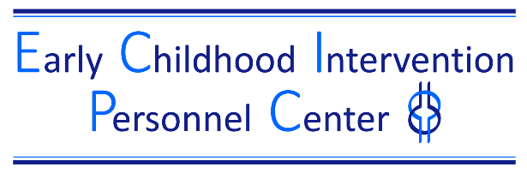

Evidence-Based Education and Training Practices for Adult Learners

The Evidence Based Adult Learning Rubric is a tool for higher education faculty and professional development providers to use when planning and implementing pre-service or in-service. The six evidence-based adult learning practices on the rubric below were derived from a metasynthesis of 15 research reviews of professional development practices and included 550 studies and 50,000 teachers and practitioners (Dunst, Bruder, & Hamby, 2015).

Examples of how to use this tool:
- Develop an assignment/activity and purposefully embed the adult learning practices during development of the material.
- Review the adult learning practices embedded within an existing training/course and identify strengths and gaps.

Who | What | How  TOPIC: Using authentic child assessment practices
Instructor/Trainer/Coach | Introduction: Explain the practice/topic/concept.
Instructor/Trainer/Coach | Illustration: Show practice/topic/concept.
Learner | Active and authentic job embedded learning opportunities: Implement the practice/topic/concept in settings in which it will be implemented.
Instructor/Trainer/Coach | Guidance: Prompt and guide the implementation of the practice/topic/concept.  Performance feedback: Provide reinforcement or corrections.
Learner | Reflection, understanding and self-monitoring: Practice and discuss with others how the practice/topic/concept works.
Instructor/Trainer/Coach/  Learner | Duration, Intensity and Follow-up: Plan for ongoing guidance and reflection for generalization and maintenance of the practice/topic/concept.
Updated 12/2024

